1. Make sure all of the amino acids are included in dict.txt. Common amino acids are already included. If you want to add new unnatural one, just added the name and formula at end of txt file in two separated lines. For example, following unnatural AA:



You need added two lines at the end of dict.txt file:

Tba (any name you want ,just make sure it matches the peptide sequence)

8, 11, 1, 2, 1 (just numbers in the sequence of CHNOS, if there is no such a element, use 0; mind the spaces between comma and numbers)

2. Put peptide sequence in peptide.txt. Make sure each AA take a single line. Use the exact name that listed in dict.txt.

For example:

Ac

b-Ala

Lys

Val

…

If the AA was protected, make sure protecting group was in dict.txt and take a new line.

3. Get the peak list of LC-MS spectrum by right click on MS spectrum and select ‘peak list. Then click ‘copy to the clipboard’ and copy it to new txt file, save as mass_*.txt. (* stand for the number of 1-9, this program can scan 9 files at once).

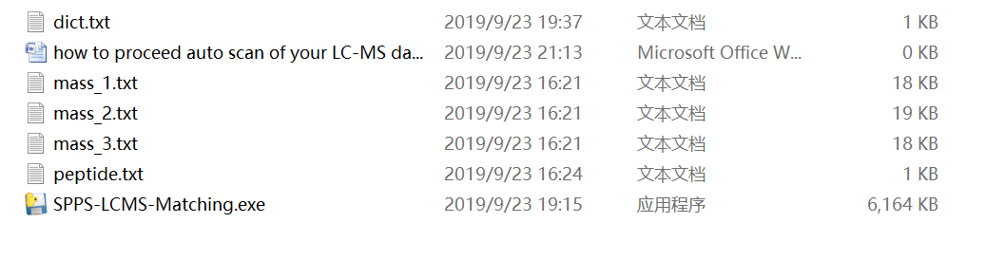

4. Double click SPPS-LCMS-Matching.exe to run the program. A window will come out and show the mass calculation of peptide. Check the result to make sure we are running a right calculation. Adjust the dict and peptide file to get right mass calculation.

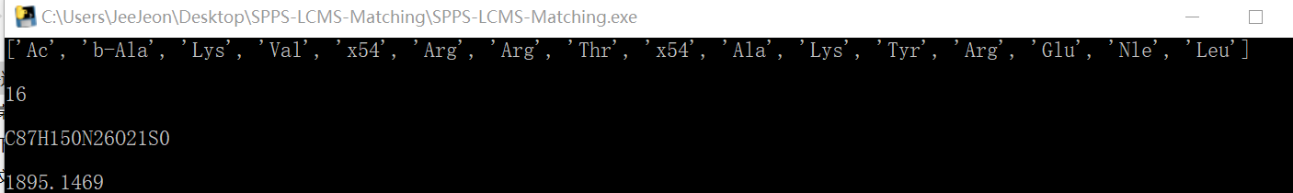

5. When the first matching is done, a message containing ‘mass_1 scanning accomplished!!!’ will come out, followed by how many seconds the matching took.

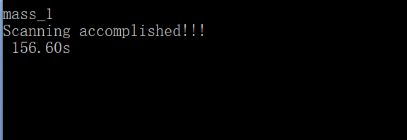

And you will find a txt file named result_mass_scan_1, which contains all the matching results.

After all matching was done, the window will close automatically. New files named ‘result_mass_scan_1-9’ come out, but only 1-3 contains data. That’s because we just input 3 mass spectrum.

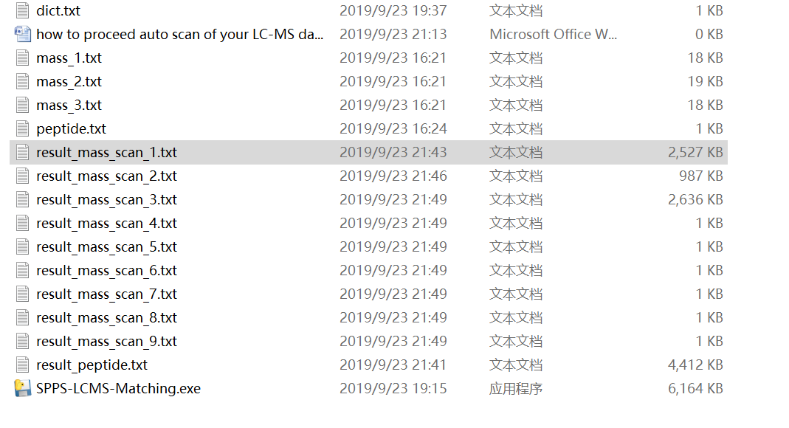

6. Open a new Excel file, import the txt data into Excel.